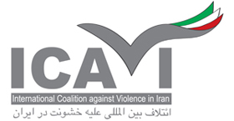
One Step Forward - Two Steps Backward
IRANIAN WOMEN SINCE THE NINETEENTH CENTURY TO THE PRESENT TIME
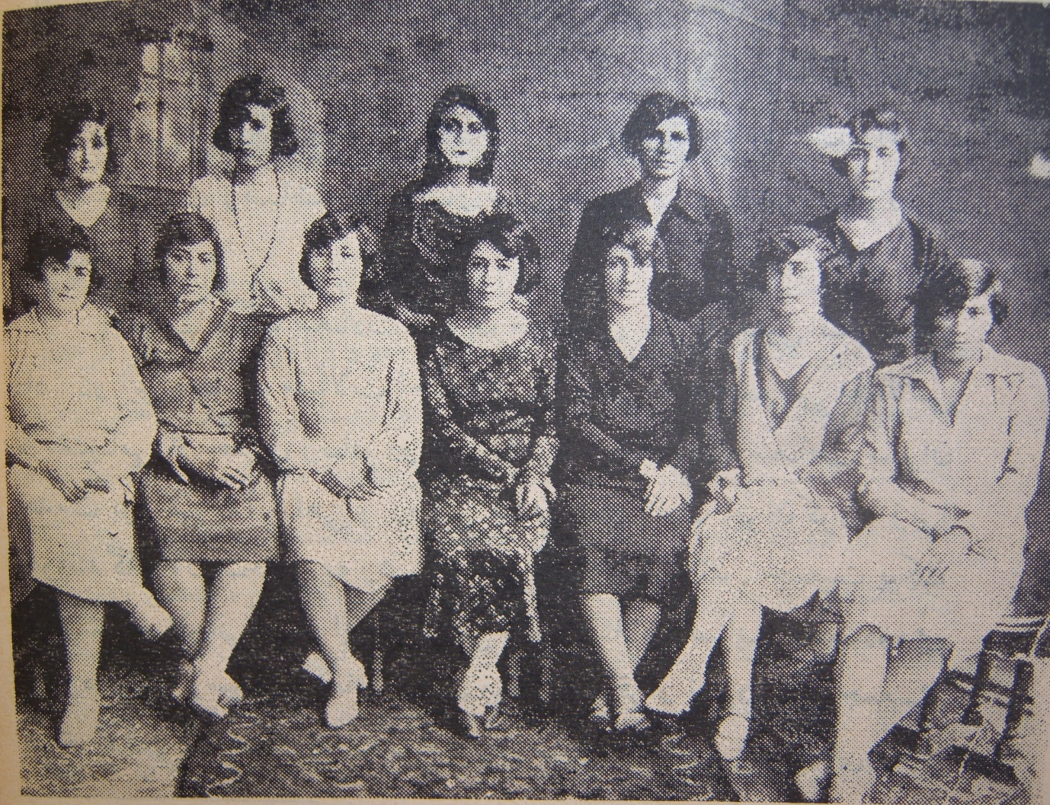
The board of directors of
"Jam'iat e nesvan e vatan-khah",
A Women's Rights Association in Tehran (1923-1933)

International Coalition Against Violence in Iran (ICAVI) Publications
This document was prepared for
“Women in the Middle East:
Challenges Amidst Growing Extremism and Violence” conference
Organised by: The Centre for Opposition Studies and
International Coalition Against Violence in Iran (ICAVI)
Tuesday 9th December 2014

Collated and compiled by Rouhi Shafii
Email:icavi@icavi.org.uk
Site:www.icavi.org.uk
Facebook/icavi

Acknowledgments
ICAVI gratefully acknowledges the valuable contribution of Nazenin Ansari, Managing Editor of Kayhan London for the historical background of this report. Our special thanks are also extended to Roya Kashefi head of human rights committee of Association des Chercheurs Iraniens (ACI) and ICAVI advisor for her editorial support.
This document was compiled through various sources including Wikipedia, and a number of on-line resources including: Justice for Iran, Iran Human Rights Documentation Centre, Al-Arabya English, Facebook and Change for Equality.
The information contained in the Appendix and some of the figures throughout the report are taken from a consultation report, “Status of Women in Iran”, submitted to the UN Commission on the Status of Women (CSW) in 2011. ICAVI directors and advisors were co-contributors to the submission.
Photographs are from Google Image archives and private albums.

Contents
Acknowledgments 3
Introduction 6
Chronology of Iranian Women’s Enlightenment and Their Political and Social Campaigns for Equality 7
Mid-Nineteenth Century to the Downfall of the Shah, 1979 7
The 1800s 7
The 1900s 8
1910 -1920 9
1920s 9
1930s 10
1940s 13
1950s 14
1960s 14
1970s 17
1978/9 - Revolutionary Years and Women 17
The Islamic Revolution and the Situation of Women in Iran 25
1980s 27
Women’s Rights Challenged on All Spheres 28
Subjugation of Women through Terror 30
Women for Women Rights 32
Women Against The Compulsory Hijab 34
Formation of Various Campaigns 36
The 9th Presidential Elections 38
Women’s Coalition and the Birth of the Green Movement 38
The Ahmadinejad Presidency and Women 42
Rohani, Promises of Moderation and Women 44
Conclusion 45
Appendix 46
Some Examples of Legal Violation of Women’s Rights in Law 46
A) CONSTITUTION 46
B) CIVIL LAW 46
C- ISLAMIC PENAL CODE 54

Introduction
The Iranian women's movement is based on the Iranian women's social movement for women's rights. This movement first emerged sometime before the Iranian Constitutional Revolution in 1910, the year in which the first Women Journal was published.
During the Pahlavi era (1925-1979), Iranian women made considerable progress. Education for both girls and boys was free. Iran’s first university admitted both men and women in 1936, when it opened in Tehran. In 1963, women gained the right to vote and run for parliament. Under the Family Protection Law, women won the right to petition for divorce and gain child custody. The marriage age for girls was raised from 13 to 18. By 1978, on the eve of Iran’s revolution, 22 women sat in parliament. There were 7 judges and 333 women on elected local councils.
Women participated in the movement against the Shah in their millions and were at the forefront of demonstrations and civil disobedience. The establishment of an Islamic state put an end to what women had gained during decades of struggles.
This document will present a short, historical account of women’s movement in Iran since 19th century to present time.

Chronology of Iranian Women’s Enlightenment and Their Political and Social Campaigns for Equality

Mid-Nineteenth Century to the Downfall of the Shah, 1979
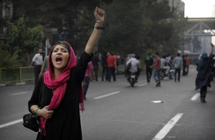

The 1800s
In March 1838, American Presbyterian missionaries opened the first girls’ school in Urumiyah, Azarbaijan, in North West of Iran. Religious minorities, mainly Armenians, sent their daughters to this school.
In 1872, under increase financial pressure The Shah of Iran, Naser-Al-Din Shah granted Concession to Reuters of Great Britain. Later in 1892, he signed another agreement with Talbot granting the sale and export of tobacco to the British for 50 years. People, especially the high ranking clergy protested against the concession and the Grand Ayatollah Mirza Hassan Shirazi issued a fatwa against the use of tobacco which resulted in street protests. Women of the royal court, who followed the grand Ayatollah more than the Shah, were part of these protests and refused to smoke the hubble bubble (ghelyan), which was widely popular in the court.
A militant women, Zeynab Pasha alongside armed men attacked government warehouses in Tabriz. At the same time the wife of Haydar Khan Tabrizi and other women armed with sticks protected pro constitution speakers in Tabriz. Zeynab Pasha (also known as Zeynab Bajie or Deh-Bashi Zainab) was very active in organizing social protests by women. It is said that she would walk in to a tea house and openly start a conversation with a group of men. She had even gone as far as taking her veil and throwing it at men saying, "If you lack the courage to stand up to those who oppress us wear our veil and go home. We will take to the battlefield instead of you.” These protests forced the Shah to cancel the agreement.
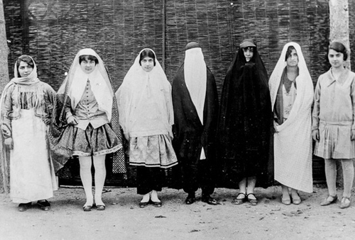
Various outfits of women before unveiling

The 1900s
During the early 1900, progressive newspapers like Suresrafil, Qanun, Soraya and Nedayeh Vatan published articles by men and women writers demanding constitutional and gender rights. In 1906, as the campaign for constitutional rights gained momentum, women from all faiths gathered and joined the strikers and when the crowds were attacked, they sought sanctuary at the British embassy along with men.
After the victory of 1906 uprising, women became involved in boycotting the import of foreign goods and raising funds for the establishment of the first National Bank. They sold their jewelry and dowries to finance the bank and native fabrics were worn to save treasury.
In 1907, the first school for girls was established by Bebee Khanoom.
The following schools were established by women: Namoos school by Ms. Tobie Azmodeh; Taraghi Banat by Ms. Mahrookh Gohar-Shenaas; Tarneyat Nessvan school by Ms. Amir-Sehi Mah-Soltan; Doratol Ma’aali school by Ms. Doratol Ma’aali. By 1913, there were 63 girls’ schools operating in Tehran.
Society for the Freedom of Women and Secret Union of Women were formed in 1907. Association of the Ladies of the Homeland was followed by The Society for the welfare of Iranian Women, Women of Iran, Union of Women, Women’s Efforts, and the Council of Women of the Center. They all played an active part in politics; organized plays raised funds for schools, hospitals and orphanages.

1910 -1920
In 1915, the Society of Christian Women Graduates of Iran was formed, followed by Zoroastrian and Jewish Women’s Association. They started organizing, helping and educating women and children in their own communities.
The Society for the Freedom of women, the most prolific of all the societies attracted prominent activists like Sadigeh Dawlatabadi, Muhtaram Eskandari, Huma Mahmudi and Shams al-Muluk Javahir Kalam. People from all faiths and men were present at the meetings.
In 1918 Sadigeh Dawlatabadi opened the first girls’ school in Isfahan. In 1927, she was amongst the first women who appeared in public unveiled.
Homa and Shams ol-Muluk were leading feminist writers and speakers. Homa was one of the organizers of a major demonstration by women outside Majlis demanding equal rights. Also a publisher and a poet she wrote constantly on women’s issues. Shams ol-Muluk, a teacher was the first Iranian woman to teach unveiled in co-educational classes in Tiflis (Georgis).
In 1910, Mrs. Kahal published the magazine Danish. This was the first journal published by a woman in Iran. By this time a large number of periodicals and magazines were in circulation.
In 1912 and 1913, Navabeh Safavi and Mrs. Ameed Mozayan-al Saltaneh published Jahan-i Zanan and Shikufah.

1920s
Sadigeh Dawlatabadi followed by Zaban-i Zanan and Zanan-i Iran in Isfahan and Tehran (1918 & 1919). Nameh Banouvan and Jahan-i Zanan were printed in 1920.
Mrs. Fakher Afagh-i Parsa, the mother of Farokh-Roo Parsa, the first woman minister in Iran, who was hanged soon after the 1979 revolution, published a magazine in later years. This magazine which was published in Mashhad and was violently opposed by religious groups forced Mrs. Parsa into exile as she had to run for her life.

1930s
By 1930s fourteen women’s magazines were discussing rights, education and veiling. Letters were sent to the Majlis; equal rights and emancipation were demanded. They were refused and the Ulma’s hostility grew further.
Reza Shah became monarch in 1925. In 1926, Sadigeh Dawlatabadi attended an International Women’s Conference in Paris. On her return, she went public in European attire. In 1928, the Majlis ratified the new dress code. All males except the Ulama (clergy) were required to dress Europeans attire at all government institutions.
In 1930 women’s hats were exempted from taxes. Emancipation was discussed constantly and encouraged by the authorities. Mirza Aboulghasem-i Azad established the first emancipation society in 1930 and was supported by Yahya Dawlatabadi another intellectual.
In 1931, for the first time, Majlis approved a new civil code that gave women the right to ask for divorce under certain conditions and the marriage age was elevated to 15 for girls and 18 for boys. The civil code was secular but family laws remained within the domain of Shariat.
In 1934, Ali Asghar-i Hikmat, the Minister of Education received orders to establish Kanoun-i Banouvan and implement reforms. Hajer Tarbyat was the first chairwomen and Shams Pahlavi the Royal appointee. Though controlled by the state, for the first time women’s activities were legitimized. The Ladies Center was not received well by the socialists and independents. They opposed royal monopoly and interference.
In 1936 Reza Shah, his wife and daughters attended the graduation ceremony at the Women’s Teacher Training College in Tehran. All women were advised to come unveiled. The unveiling of women was officially born.
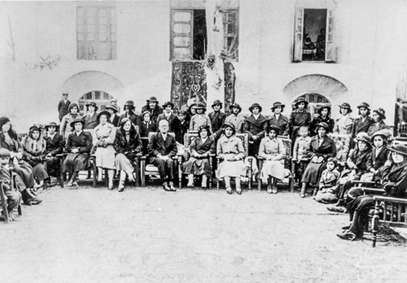
Celebrating the unveiling period 1936
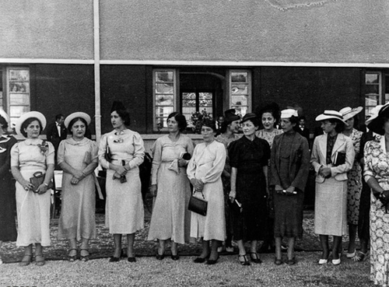
Women at a ceremony for the unveiling, 1936
As publicity and propaganda for unveiling did not work, unveiling was made compulsory and women were barred from wearing chador and scarf in public. Across the country gatherings and celebrations were held where officials and their wives were ordered to attend unveiled.
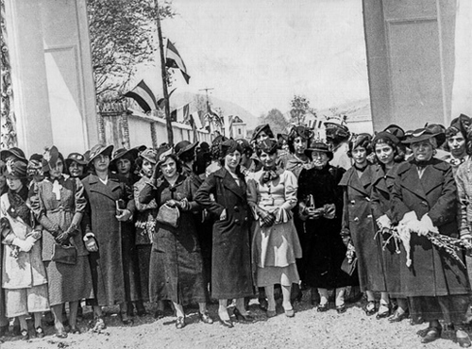
A number of women in the new outfits during the unveiling period 1936
A national education system was formed to educate boys and girls equally. In 1936, the first females entered Tehran University. Shams al Moluk Mosaheb, Mehrangiz Manuchehrian, Zahra Eskandar, Batul Samei, Tosey Haeri, Shayesteh Sadegh, Taj Muluk Nakhaei, Forough and Zahra Kia, Badr al Muluk Bamdad, Shahzadeh Kavousi and Saraj al Nesa (from India) were admitted. Amineh Pakravan was the first female lecturer and Dr. Fatimah Sayah the first woman who became a full professor.
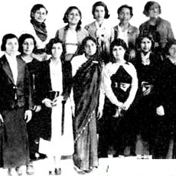
The first group of women university students, 1936

1940s
In 1942, Safiyeh Firouz formed the National Women’s Society and the newly formed Council of Iranian Women in 1944 strongly criticized polygamy.
In 1944, Huma Houshmandar published ‘Our Awakening’ magazine and in 1949 the women’s league was changed to Organization of Democratic Women which was part of the Tudeh Party (official communist party in Iran) and branches were opened in all the major cities. Zahra and Taj Eskandari, Iran Arani, Maryam Firouz, Dr. Khadijeh Keshavarz, Dr. Ahktar Kambakhsh, Badri Alavi and Aliyeh Sharmini were amongst the best known Tudeh activists. The society was later changed to Organization of Progressive Women and in 1951 unsuccessfully lobbied for electoral rights. Mohammed Mossadegh’s removal from power in 1953 put an end to independent organizations.
In 1949, the Higher Council of Women was formed headed by Princess Ashraf Pahlavi, the Shah’s twin sister. The council opened branches all over the country focusing on health, education and charity work.
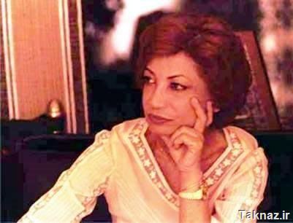
Ashraf Pahlavi championed welfare for women from above

1950s
In 1951, Mehrangiz Dawlatshahi (the first female Ambassador) formed Rah Naw and with Safeyeh Firouz founded the first organization supporting human rights. The two met with the Shah and demanded electoral rights. Opposition by religious authorities ended the debate.

1960s
The 1960s Iran was a decade of awakening and change for women, inspired and in line with women’s movement in the West and the reforms from within. More women entered the university and the workforce and the strategy of rapid development demanded further rights for women.
In1963, under various reforms by the Shah, women were granted the right to elect and be elected by to the parliament. This act was vehemently opposed by Ayatollah Khomeini who spoke against women’s rights and was consequently sent to exile, first to Turkey and then Iraq, where he stayed for 15 years and grew the seeds of an Islamic state.
By 1964, the Higher Council of Women set up in 1949 By Ashraf Pahlavi changed to Organization of Iranian Women and in 1978, had 349 branches, 113 Centers and covered 55 other organizations dealing with women’s welfare and health. The last registrar indicates that in 1977 alone, over a million women used the services. Most centers were trashed after the revolution.
Before the Revolution, Asraf Pahlavi served as a delegate from Iran to the United Nations for sixteen years. She was participated in the Human Rights Commission, the Commission on the Status of Women, and International Consultative Liaison Committee for Literacy. She also served as vice president of the Imperial Organization for Social Services and as president of the High Council of the Iranian Women’s Association. In recognition of her work, she received an honorary degree from Brandeis University in 1969. Among other accomplishments, in 1975, the International Women’s Year, Ashraf presented a declaration on the inequality suffered by women throughout the world to UN Secretary General Kurt Waldheim.
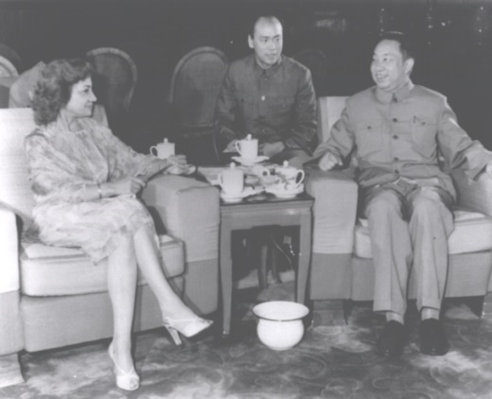
Ashraf Pahlavi & Cho-En-Lai of China
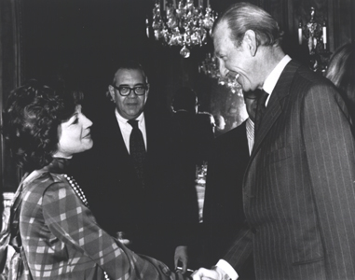
Asharaf Pahlavi & Kurt Valdheim UN General Secretary
In 1965, the International Convention on the Elimination of All Forms of Racial Discrimination was approved by the UN. In 1966, International Covenant on Civil and Political Rights and International Covenant on Economic, Social and Cultural Rights were approved.
In 1967, the Family Protection Law was ratified. The law acknowledged women's rights for their own sake and challenged, for the first time, men's authority within the family. A man could no longer marry an additional wife without the consent of his first wife. He was not automatically granted the custody of his children. The Islamic Republic proceeded quickly to re-institute the patriarchal family. Two weeks after the Revolution, on 26 February 1979, the Family Protection Law was rescinded.
In 1968, the Family Protection Law was further ratified. Divorce was referred to the family courts, gains were made with respect to divorce laws, polygamy was limited and required first wife’s written consent. Marriage age for girls was set at 18 years. Mrs. Parsa became the first women minister in Iran. Women were required to serve the education corps and pass military service.
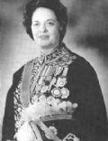
Dr Farokh-Roo Parsa, Education Minister
In 1969, two years after returning to Iran as a professor of literature and Chair of the Department of English at the National University of Iran, Mahnanaz Afkhami, founded the Association of University Women and was drawn into Iran's women's movement. In 1970, she became the secretary general of the Women's Organization of Iran (WOI). She remained at the head of the WOI for ten years during which she worked for Iranian women's rights. During her time as Minister of Women's Affairs, Iran's legislation granted women equal rights to maternity leave and childcare provision, and built upon the family laws of 1967. Afkhami served as a member of Iran's High Council of Family Planning and Welfare, the board of trustees of Kerman University, and the board of trustees of Farah University for Women.
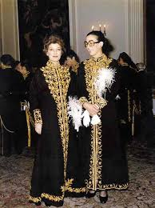
Mahnaz Afkhami, Minister for Women

1970s
In 1975, women gained the right of guardianship for their children after their husbands’ death. Abortion was never legalized but the existing penalties were omitted and this made it a lot easier. Shari’a remained in the law but Ulama’s response was drastic. Fatwas by known figures including Ayatollah Khomeini declared the move heretic, demonstrations followed but were put down. By 1978, 33% of university students were female with 2 million in the workforce. 190,000 were professionals with university degrees. There were 333 women in the local councils, 22 in Majlis (parliament) and 2 in the Senate.
Also in 1975 Ashraf Pahlavi, was heavily involved with the International Women's Year, addressing the United Nations. At the same time, Queen Farah promoted her own interests which were art, musical festivals and exhibitions. The Shah of Iran became an international figure and as president Carter put it: Iran became an “Island of Stability” in the Middle East.

1978/9 - Revolutionary Years and Women
During the uprisings of 1978-1979, which terminated the 2,500 years monarchy in Iran, women of various backgrounds and trends of thought participated in street demonstrations and workplaces and paralysed the state apparatus. However, the majority of the women on the street demonstrations came from religious families and took to the streets when Ayatollah Khomeini asked his followers to take to do so. In later years, these category of women entered universities and job market, replacing thousands of secular women who had been forced to either resign, retire or dismissed.
At the time, the only factor which grouped women was the overthrow of the Shah. It was a common, unwritten, perception that if the regime changed, peoples’ standard of living, socially, economically and especially politically will improve.

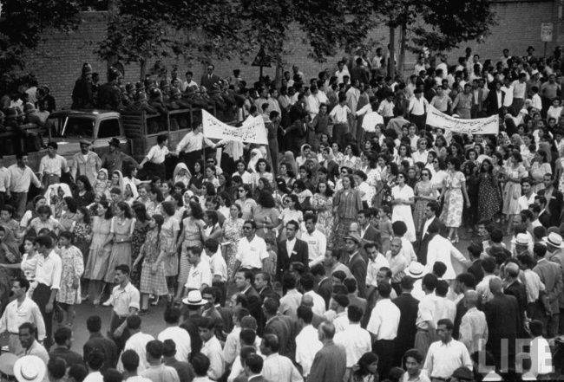
Women at a demonstration in 1950s
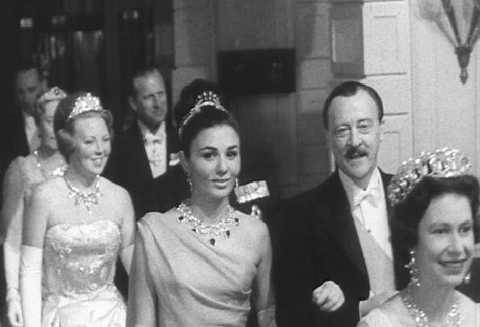
Queen Elizabeth, guiding Queen Farah in a banquet in England
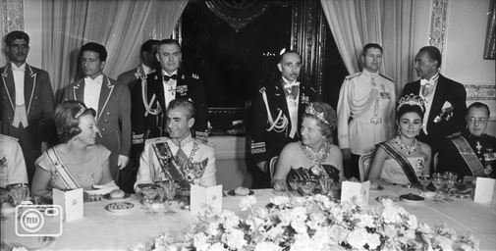
The Shah & Queen Farah at a banquet with Queen Juliana of the Netherlands
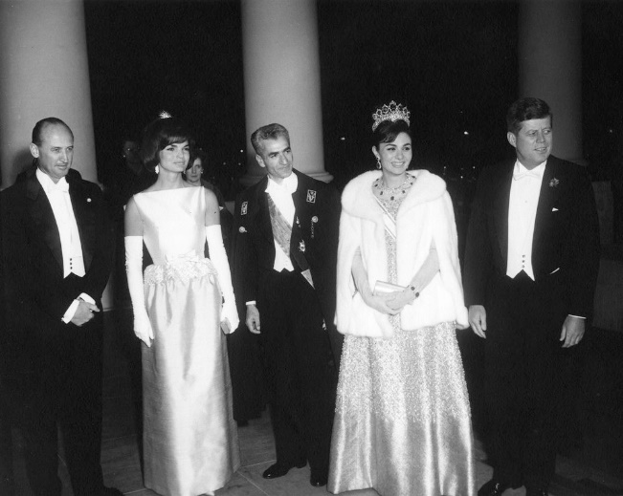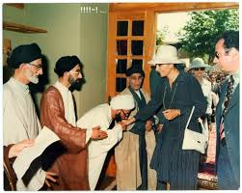
The Shah & Queen Farah at the White House Cleric kissing Queen Farah’s hand
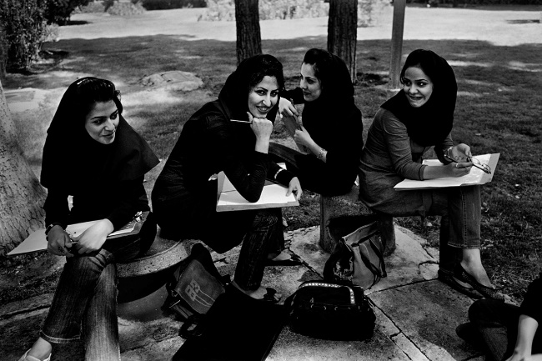
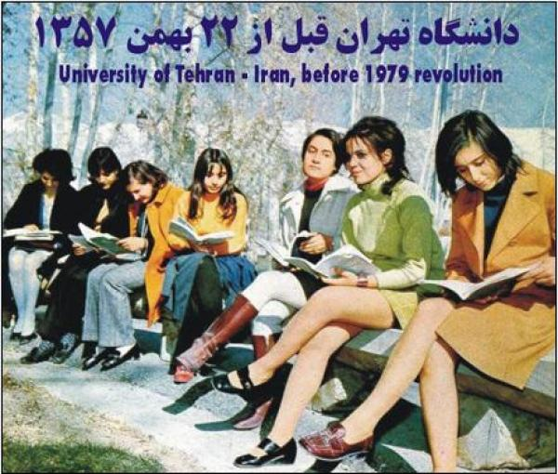
University students at present University students before revolution
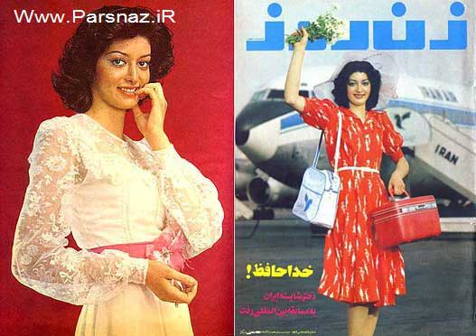
Covers of women magazines in 1970s Iran
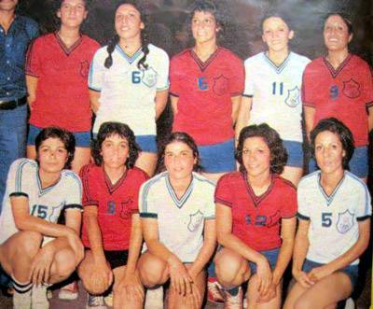
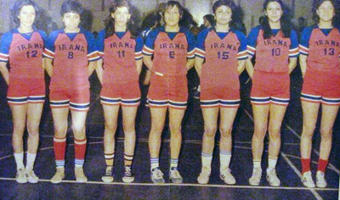
Teams of women athletes 1970s Iran
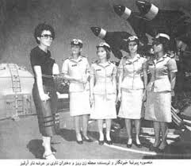
Women in the Navy 1970s with reporter Mansoureh Pirnia

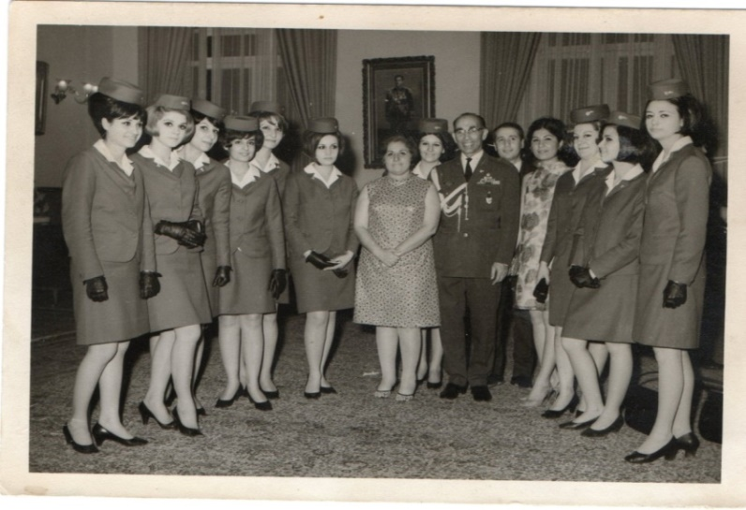
One of the first groups of Iran Air flight crew in 1960s. The airline was ranked top in the world.
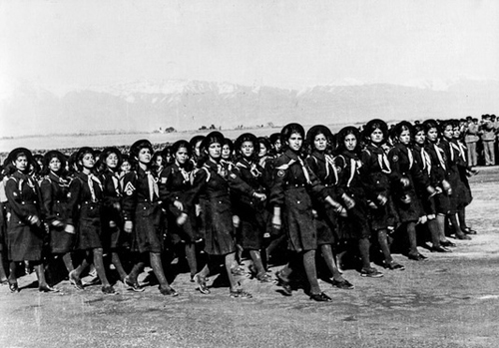
Women were sent to villages as part of literacy corps
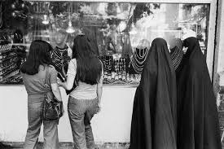
Living in harmony side by side, 1970s
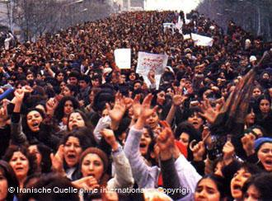

Anti-Shah Demonstrations

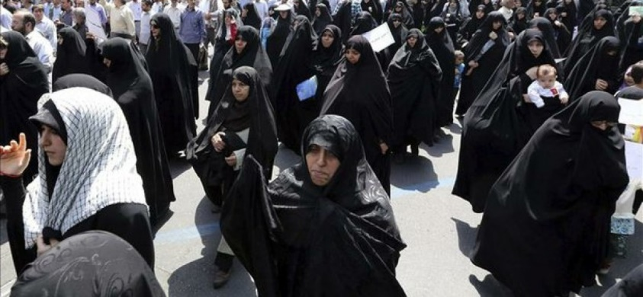

Anti-Shah demonstrations

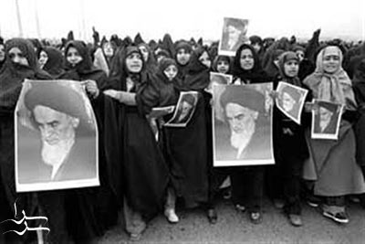

Ayatolla Khomeini supporters
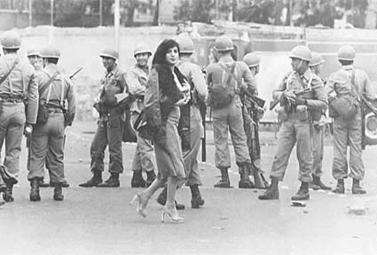
During the unrests of 1978, a woman is crossing the streets while soldiers look on
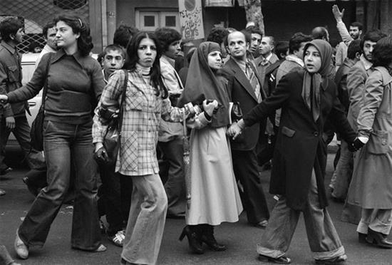
A revolution for all!?

The Islamic Revolution and the Situation of Women in Iran
In October 1978, while still in Paris, Ayatollah Khomeini, who had suddenly been accepted as the leader of the opposition, in response to a question put to him by Russel Kerr, (a British Labour MP who met him along with some British delegates) regarding the status of women. Khomeini said: “In Islam, women and men are equal and they will be treated as humans. You should not listen to publicities which is raging against us”.
However, this declaration of equality of men and women which he repeated in various interviews did not materialise once Ayatollah Khomeini took to power and declared Iran an Islamic state. Women became the first targets of the Islamization of the country. Women became the symbol, the banner and flag of Islam in Iran.
The first official response to the issue of hijab was on March 7, 1979. Less than a month after the revolution, while public harassment of women lacking hijab at the hands of religious revolutionaries continued, Ayatollah Rouhollah Khomeini, Iran's supreme leader, referred to unveiled women as "naked" and demanded that they observe Islamic hijab at offices and places of work. It was during his speech at the Refah School that Khomeini stated:
"At Islamic ministries women should not appear naked. Women can be present so long as they are with hijab. They face no barrier to work as long as they observe Islamic hijab. The next day, which coincided with International Women's Day, thousands of women marched in the streets of Tehran to protest against organised attacks against women who opposed hijab. Their slogans during the demonstrations against "those who have attacked women without the veil" are indicative of the continued violent attacks against women without hijab. According to reports on events of the day by Kayhan newspaper, "a group of men at Valiahd Square attacked a number of women without hijab and when they threw stones at men several women were injured.
During the first weeks and months after the arrival of Ayatollah Khomeini in Iran and his residency in a school complex (Alavi School), the country was in total chaos. Those who had high positions in the Shah’s administration were frantically finding routes to escape the country. Tens (200 or more) of these officials were captured and hurriedly and unceremoniously without trial were executed on the roof of the school. Among them were the ex-prime minister, Hoveyda who was shot and the first Woman Minister of Education, Dr Farokh-Roo Parsa who spent all her life educating girls and who was hanged.
On 1 April 1979, a national referendum in was carried out in which one question was put to the vote: “Do you accept an Islamic state?” As was expected, %98 of people voted for the establishment of an Islamic state. A decision most regretted in later years.
A delegation of experts began work on the new constitution. The Constitution of the Islamic Republic of Iran was adopted by referendum on October 24, 1979, and went into force on December 3 of that year, replacing the Constitution of 1906. It was amended in July 28, 1989. The Constitution incorporated articles which were discriminatory to women and religious minorities as were articles in the Civil Code and the Islamic Penal Code which were gradually introduced.
Before the written laws came to force, women were put under pressure to regard dress code, to behave as Muslim women should do. Meanwhile women took part in street demonstrations against the new order. When female judges and 500 female law students were expelled, hundreds of women had a 3 day sit-in protest at the ministry of justice. The newly established revolutionary guard attacked them and expelled them from the building.
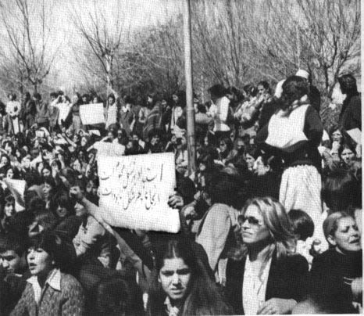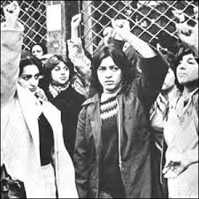
Demonstrations against the Hijab, 1979
Throughout 1979, women organisations and groups alongside ordinary women demonstrated their objections to the laws which gradually appeared to come into effect.
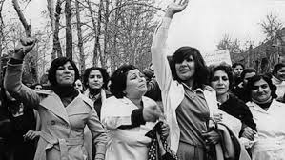
Women against the Hijab,1979

1980s
In 1980, the occupation of the US Embassy by a group of students and the hostage taking of the Embassy staff created a hotbed for self-appointed groups of thugs as well as appointed corpses to target any demonstration and gathering either other groups outside the system or women.
In September 1980, Iraq declared war with Iran by invading parts of southern provinces and even attacking Tehran Mehrabad airport. The war was a God-sent omen which mobilised all groups to defend the country and all other matters went under the shadow of war. Iran-Iraq war which lasted 8 years consolidated the foundations of the Islamic Republic.
During 1980-83, under the banner of Cultural Revolution, all universities were closed down. A programme of purge and replacement ensued where, 20,000 teachers and 7,000 lecturers and university professors and thousands of students were expelled and replaced by supporters of the regime. The purge and replacement ensued in the government organisations and the army, where 8,000 military officers were expelled and the army became a weak institution, replaced by the revolutionary guard.
Throughout the 1980s, a wave of arrests, imprisonment, torture and mass execution of members and supporters of political groups and organisations outside those close to the ruling group forced many to go underground or get out of the country. Thousands of women especially young supporters of the Mojahedian-e Khalq & the Fadais were imprisoned and girls as young as 12-13 were executed for their affiliation. Before execution female prisoners were raped by the guards as in Islam if you killed a virgin, she would go to paradise. Those who survived and spent years in prison never lived a normal life. Some women however published their memoirs of the harrowing years behind bars. So far, over 40 books of prison memoirs had been published. The climax of crimes was in the summer of 1988, where under the direct order of Ayatollah Khomeini, over 5,000 prisoners were murdered, among them a number of women.
As a result of the Cultural Revolution in 1981, women were barred to study in the 91 fields out of 169 fields at the higher education. In line with this policy unmarried women were also barred from studying abroad unless they were married and accompanied by husband.

Women’s Rights Challenged on All Spheres
The policy of gender segregation continued alongside the strategy of changing minds towards discrimination against women, ethnic and religious minorities. In a recent directive issued across Tehran’s municipal and city councils, association of men and women is barred during office hours. Employment of women as typist and secretary is also banned. This directive has the support of a number of MPs and other organisations are encouraged to follow suit. In a separate directive, employment of women in the coffee shops and traditional restaurants is banned. Furthermore, in 16 cities, women singers are barred to accompany males in duet performance.
The establishment of a corpse called “Oppressed mobilisation” and Hizbollah (the party of God) comprising of loose thugs and above all the formation of the revolutionary guards took Iran to the road towards a totalitarian Islamic state. In 1982, the Islamic Penal Code on “Veil & Chastity” was drawn which in Article 638 states: "Women, who appear in public places and roads without wearing proper Islamic hijab, shall be sentenced to ten days to two months’ imprisonment or a fine of fifty thousand to five hundred Rials."
In practice, the punishment went further than what was stipulated in Article 638. Over years, the biggest challenge the regime faced came from millions of women who refused to comply with the order. Gradually, further decrees were added: stockings, colour and type of scarves, colour and models of shoes, necklace, bracelet, earring, bags, winter shawls, glasses, belts and etc. In a circular issued by one of the many commissions on the veil, make up, and even prints on the rings and other accessories which showed animals such as wolves and foxes (these animals were referred as wicked and lustrous in myths) were banned. These commissions set out necessary details on the segregation of men and women and as well as dress code. Details of decisions were circulated throughout the entire country to almost all organisations which had already established their own internal policies on the veil and segregation.
The financial cost of creating various official and un-official organisations and corpses to track down, threaten, attack, detain, fine, harass and torture women, physically and psychologically is beyond calculation. Yet, generation, after generation of women who were reluctant to be dictated their way of self-expression and appearance had deprived the regime the satisfaction to bring them under control.
Stated in a report compiled by a number of women activist and sent to Commission on the Status of Women (CSW) in 2011, during the first three months of 2010, 87,000 women received verbal warnings at the airports and other public places regarding their dress code. Out of this number, 33,029 were allowed to continue with their travelling after they changed clothes. Another 30,506 gave guarantees in writing to observe the official dress code.
Also, a number of women who had been at the airports to welcome a traveller and whose outfit seemed ‘inappropriate’ were prevented from entering the airport reception areas and the case of 71 women was referred to the judiciary.
According to NAJA, (Nirooy Entezami–The Police) website, the combination of 1,524 women who were detained and reprimanded on the basis of ‘improper Hijab’ on the streets of Tehran in recent months indicates that ‘there has been no conspiracy in the matter of Hijab but simply due to lax supervision.

Subjugation of Women through Terror
Extreme measures such as chain murders of women in various stages since 1979 had been another attempt to terrorise half of the population. A few years ago in the cities of Mashhad and Kerman, tens of women were murdered in a chain of events, where no one ever claimed responsibility. In recent months, women have been attacked by acid which so far has disfigured more than 10 (official figure) in the city of Isfahan. Acid attacks followed a renewed campaign against women’s, where at the parliament ‘leggings’ women wear were shown as manifestation of corruption and Western-style dress which one deputy announced “is ruining the country’s morals and must be dealt with by the state or the people themselves (meaning groups of organised thugs)”
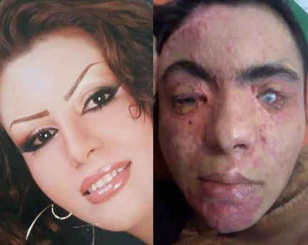
A victim of recent acid attacks
A number of Ayatollahs spoke in the Friday prayer sermons of the vice women’s public appearance brings to the moral of the people and warned that it should be addressed verbally or else. In Isfahan and Tehran men and women demonstrated against the renewed wave of acid attacks on women and demanded the authorities to find and bring the criminals to justice,. The results were the detention of a number of demonstrators, a reporter and two of the most famous women’s rights activists and former prisoners; Nasrin Sotoudeh and Mahdieh Golroo. Nasrin was released after a few hours following interrogation.
In 2003, Zahra Kazemi, a Canadian –Iranian photographer was arrested in front of the Evin prison. A week later he bruised, raped body was delivered to her mother, who was threatened not to speak out. Her murderers were never brought to justice.
In October 2007, a young, gifted doctor, Zahra Baniyaquoob was arrested in a park in the city of Hamadan while walking with her fiancé. Few hours later, she was dead. Her murder was never properly investigated and no one was brought to justice for her murder.
In 2009, and during mass demonstrations against the rigged presidential elections, Neda Agha-Soltan, a young university student was shot dead in front of world media. Many more women were beaten, detained and tortured during and after the mass movement.
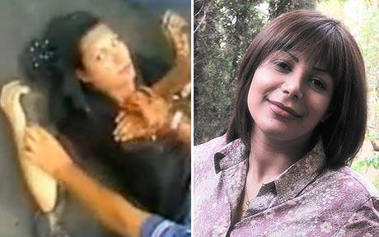
.Neda Agha-Soltan, a university student who was shot dead on the street, July 2009

Women for Women Rights
In the early years of the revolutions and due to the extreme repression, women organisations were dissolved and activists either fled the country or were detained and spent years in prison. During the 1980s Iran’s prisons were filled with men and women from various backgrounds, mainly political activists of the Left or the Mojahedin Khalgh ( an Islamic group opposed to the regime). Many prisoners were women and young girls who were systematically tortured and later killed. Young girls who were sentenced to death were raped before execution as Islam believes that if you kill a virgin she would go to paradise. The cases of rape were not limited to those who were to be executed. In some prisons women were raped by their interrogators. Many women had spent years behind bars. Over years, Iranian prisons had never been empty of women.
In the 1990s, a number of independent women activists were introduced to feminism and western ideas of women’s rights. After the revolution, only communist ideas of women’s equality and trends of thoughts of women such as Rosa Luxamburg and Clara Zetkin were known to women activists whose majority were members or supporters of political organisations.
Gradually, when universities and higher education institutions opened after 3 years, women entered universities in large numbers and over years took over men in a number of fields. During the 1990s and early 2000, the number of women soared over years. These enlightened, educated women demanded a place in the society equal to that of men. Yet, the Islamic regime brought forward further discriminatory laws to limit their presence in the higher education and more vigilantes to the streets to restrict their free movement.
In mid-1990s, debates and discussions among secular women as well as moderate Muslim women flourished on the rights of women, re-interpretation of the Sharia and women in a modern society. The efforts and campaigns of women activists who had left Iran and who published magazines (Nimeyeh Digar in particular), published books and research papers and organised annual conferences (Annual Women Studies Foundations conferences since early 1990s) contributed to the emerging women’s movement in Iran.
The publication of a feminist magazine (Zanan) in Iran which gave space to debates and discussions on women and their rights was a milestone in this period of women’s awareness of their rights and shortcomings. Articles by women lawyers were regularly published in which discrimination against women in law were explained and explored. A re-read of archaic, Islamic texts were introduced by some enlightened clergy and women scholars from both secular and Islamists side questioned the discriminatory laws which put them in the inferior position they were in and demanded change and amendment.
As a result of women academics and activists’ campaigns, the field of Women Studies at the Masters level opened in 3 universities: women only university, Alzahra, Alameh Tabatabai University and University of Tehran. However, in 2012, Gholam Ali Hadad, head of the Council of Human Sciences announced that Women Studies field had been changed to Family and women’s rights in Islam.
Another area where women got heavily involved, as soon as it opened up in Iran, was the use of internet and social media. The government put numerous restrictions on the use of the internet and criminalised activities it considers “against national security”. Nevertheless, millions of Iranians especially women use the internet, FaceBook and blogs to express themselves and communicate with others.

Women Against The Compulsory Hijab
The biggest hurdle which has kept women and the Islamic regime in constant conflict since 1979 is the dress code and the hijab. The Bill on compulsory hijab past 3 years after the Revolution. Although the government allocated huge resources and vast number of organisations and corps to ward off the Islamic hijab, generation after generation of women have defied the strategy and confronted the establishment in whatever method they found suitable to demonstrate their objection. In the 1990s, during Hashemi Rafsanjani presidency, he ordered the import of millions of meters of black fabrics for chador as it was considered the best form of hijab. Rafsanjani was the first official who spoke of the “benefits of temporary marriage”.
In 2005, just before leaving office, and in pursuant of the development of “Culture of Chastity and Hijab”, president Khatami issued a Directive to all government organisations, police and revolutionary guards to uphold the hijab issue. He also ordered the customs to relieve imported black fabrics for chador (from official cover) from custom’s duty. The consequence of this directive was reflected in the decisions taken by Ahmadinejad’s government to impose further limitations on women.
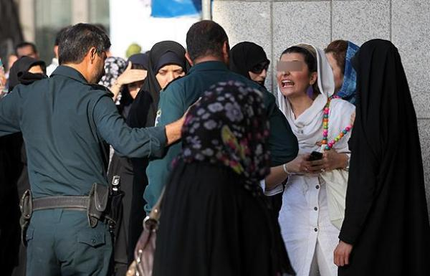
Harassment of women on the streets is a daily experience
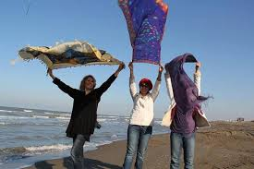
‘Stealthy Freedoms’, is a Facebook campaign administered by journalist Massih Alinejad who asked women to demonstrate their choice of dress. Many women have sent their photos with displays of ‘freedom from the compulsory Hijab’. Over 600,000 have ‘liked’ the page.

Formation of Various Campaigns
In 2006, a group of women started a campaign to collect one million signatures against the discriminatory laws in Iran. The Campaign for One Million Signatures demanded changes to discriminatory laws and asked for the elimination of all forms of discrimination against women. The Campaign for One Million Signature whose initial signatories were 100 women, found a broad-based appeal among grass roots and its branches spread all over Iran and abroad. Although the Campaign managed to mobilise thousands of women and won a number of international prizes, many of its founders were arrested in a demonstration in one of Tehran’s main Square (Haft Tir) and spend time in prison.
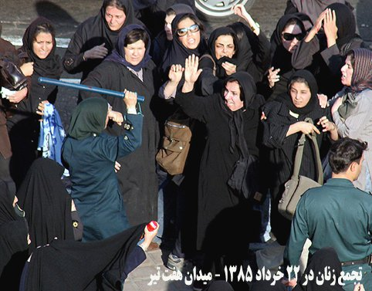
Women demonstrators at Haft Tir Square, 2007
When the court was in session to hear the cases of women detainees, a number of women held a silent demonstration outside the court. Around 33 of them were detained and taken to prison.
Over the years women set up various campaigns including:
- Campaign against gender ratio in universities.
- Against stoning.
- Open stadiums to women.
- Campaign against unlawful pressure on women’s rights activists.
- No to gender segregation in school books.
- Mothers for peace – ‘Madaran Solh’
- Women’s Coalition – ‘Hamgaraie Zanan’
In 2008, the government introduced a new Family Protection Bill to reduce the amount of alimony (Mehrieh) which is stipulated to the marriage contract and works as a guarantee for women during divorce. The Bill also sanctioned polygamy, where the man was allowed to marry twice without the first wife’s knowledge. This Bill was opposed by women’s rights activists inside and outside Iran and the two items were later removed in the final approved Act..

The 9th Presidential Elections

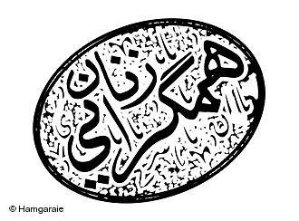
Women’s Coalition and the Birth of the Green Movement
In the months prior to the 9th presidential elections, a group of women activists formed a coalition to campaign for the candidate who would incorporate women’s demands in his manifesto. This coalition which in later months developed into the biggest collective work of Iranian women on political participation, inside and outside the country, gained momentum during the months prior to the election. The coalition published a manifesto stating its demands and for the first time in Iran’s history of presidential elections, women became an independent force to be taken seriously. Presidential candidates were forced to respond to women’s demands in various ways. Zahra Rahnavard, wife of one candidate, Mir-Hossein Mousavi, who got involved in the coalition, went even further to say to CNN's Christiane Amanpour:
"Thirty-four million women demand to have female Cabinet ministers; Thirty-four million women demand to be eligible to run for president.”
"Thirty-four million women want the civil law to be revised; Thirty-four million women want the family law revised."
Rahnavard broke barriers for women just by appearing on the campaign trail with her husband, a rarity for political wives in Iran. Mehdi Karoubi, another candidate offered his campaign headquarters to women activists making the issue of Hijab and freedom of choice a campaign point.
After the presidential elections, where Ahmadinejad was declared the winner, people took to the streets to demonstrate against the elections results which they believed were rigged. Women constituted a large force in these street demonstrations. The movement against elections results which lasted about 9 months and died down as a result of extreme brutality was later named the Green Movement. During this period many were killed, injured or disappeared. Thousands were detained, among them many women. As Mir-Hossein Mousavi, one of the hopeful candidates refused to accept the results, he and his wife, Zahra Rahnavard, along with Mehdi Karoubi and his wife were taken under house arrest and never been allowed out, nor tried and convicted.
Mourning Mothers of Iran, consisting of a number of women and their supporters was born out of the campaigns of mothers who lost their children during the Green Movement. Women activists outside Iran formed Supporters of Mourning Mothers of Iran and held vigils in major cities to the plight of mothers who wanted justice for their children. The Green Movement was the only organised mass movement against the Islamic Republic after the 1979 revolution and attracted millions especially young men and women. Yet, extreme brutality, mass detentions, torture and long prison sentences on the one hand and lack of coherence and strategy of its leaders on the other resulted in its silence and stagnation.
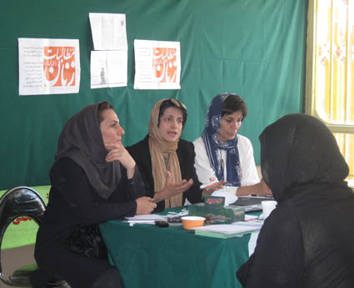
A workshop organised by ‘Women’s Coalition’ in Tabriz prior to the 2009 presidential elections

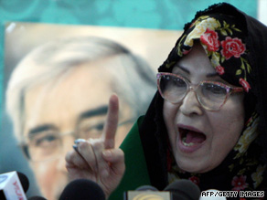
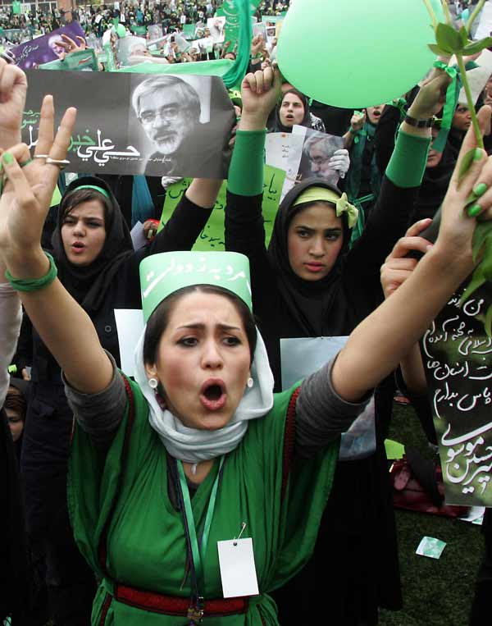

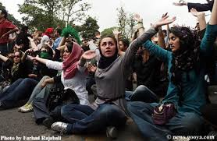
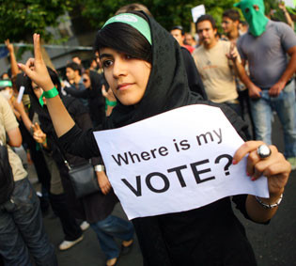

During the uprisings following the disputed 2009 presidential elections women were visibly
the driving force in demonstrations.

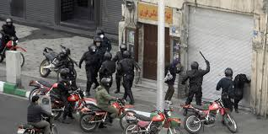
Police & security forces, attacking women, 2009

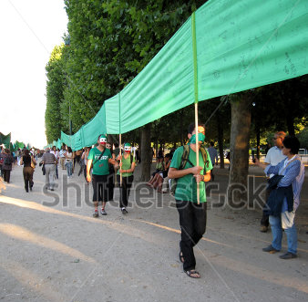
Outside Iran, the slogan, “Where is My Vote” was written in a banner of 2 kilometres and shown across Europe and North America.
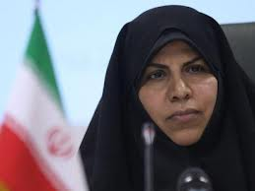

Marzieh Vahid Dastjerdi, minister of health in Ahmadinejad cabinet

The Ahmadinejad Presidency and Women
During the 8 years of Ahmadinejad presidency, the situation of women worsened dramatically. Various legislations were introduced and passed by the Islamic parliament which targeted women.
- The Bill to relax polygamy and temporary marriage
- The Bill to limit the ratio of women at higher education. Women we barred to study in the 77 fields out of 212 fields at the higher education.
- Limiting the number of women in the field of Medicine which was ratified in 2008.
- Ratios at the level of masters and PhD’ degrees to limit the number of women.
- Segregation of fields of study and banning women to study certain fields.
- Regionalisation of gender in higher education for women. This meant that women who had higher marks than men in the university entrance exams and had the chance to attend a better university outside their residence.
- Separation of text books for boys and girls at the elementary and secondary schools with the aim of teaching girls traditional, gender specific roles.
- An article in the Bill on adoption which allowed the father to marry his adopted child.
- The policy of population increase and legislation to ban birth control devices, vasectomy and further restrictions on abortion
- At the employment level, priority is given to married men with children, married women with children and single, independent women are placed at the bottom
- Iran has more than 1,300,000 women head of family who support up to 5 members. Yet, in law, the man is recognised as head of family.
- Legislation & directives on Hijab, Khatami’s legacy worsens during Ahmadinejad as he implements and enforces the contents of the directive which Khatami issued to all government organisations regarding the “Policy of Hijab & Chastity”.

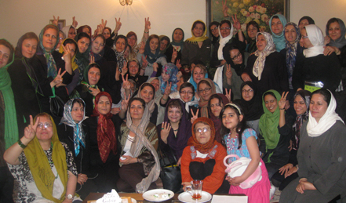
A number of women activists, 2010

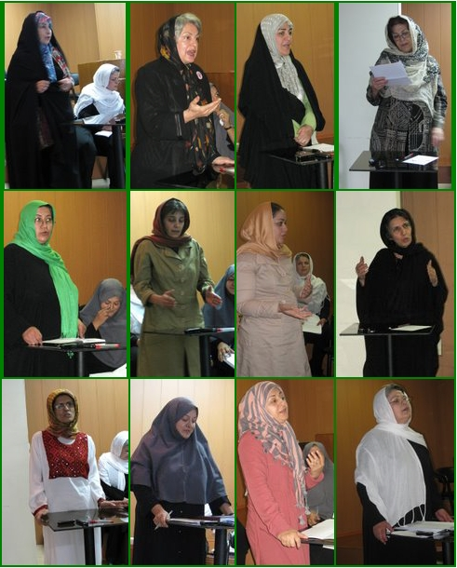
A number of women’s rights campaigners speak at various events

Rohani, Promises of Moderation and Women
In August 2013, Hassan Rohani, a PhD graduate of law school in Britain, won the 10th presidential elections with over eighteen million votes. Women comprised a big proportion of voters. Hassan Rohani’s presidency began with promises of further transparency and openness and reviving Iran’s stance in the international community. On the issue of women, Rohani stated that there is no difference between men and women and promised creating more opportunities for women including setting up a ministry for women.
In the first months of Rohani’s presidency hopes were raised by some that he will meet up to his promises on women as he appointed 2 women deputies and a spokeswoman for the foreign ministry. He later appointed another female deputy on women and family affairs. Hassan Rohani published a Citizens Charter which was circulated and debated among women who presented recommendation and amendment to the text, hoping it will find its way into law and practice.
However, in a matter of months hopes turned into despair as the situation of human rights deteriorated and executions increased and citizens’ freedoms were tightened.
Although the vice president for Women and Family has tabled several proposals and spoken extensively on the rights of women, the situation on the ground portrays a different picture. The bill “Promoting Virtue, Preventing the Vice”, allows every individual to take the law into his hand and attack others, which already taken the life of one young man who tried to stop a group of men harassing some women.1
Based on such policies, attacks on women have increased. Apart from acid attacks in September 2014 in Isfahan, at the time this report is compiled several women have been attacked by knife in the city of Jahrom by a young man who said when captured: “He was acting as he thought was right”.
The bill on population increase which was ratified during Ahmadinejad presidency is still in place and birth control devices are under strict rules. Women are deprived to consciously decide on the size of their family. Employment of single women has faced restrictions as priority is given to married men with children and married women with children. The policy of segregation has developed into work places and women are barred to work in coffee shops. Hassan Rohan’s promises of creating opportunities for women and a free society has not materialised, nor has his promise of bringing Iran out of isolation. The picture outside Iran is that of a young woman being imprisoned for wanting to watch a match and every thug is given the right to attack any women under “Promoting Virtue, Preventing Vice”.

- http://www.rferl.org/content/iran-lawmakers-look-to-protect-vigilantes-of-islamic-justice/26668192.html
http://rc.majlis.ir/fa/legal_draft/state_popup/889995?fk_legal_draft_oid=880288&a=download&sub=p

http://bidarzani.com/17194
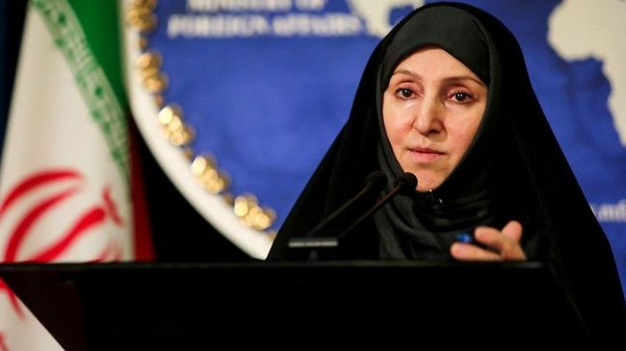
Marzieh Afkham, Foreign Office spokeperson in Rohani cabinet
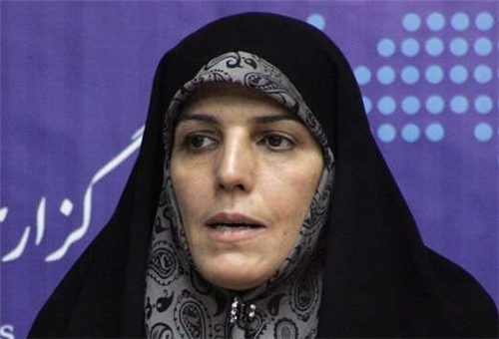
Shahindokh Moulavardi, Vice-president for Women & Family

Conclusion
Iranian women are among the first to rise and demand equal rights as far back as early years of the 20th century. Apart from Egypt which has similar history of the women’s movement in the Islamic world and Turkey which became a secular state and granted women a number of rights in the 1930s, no Islamic country has such long history of women awakening for their rights. This long, rich history had been the backbone of present struggles of the Iranian women to never subjugate to the forces of backwardness, fundamentalism and extremism.
While during the uprising in the Middle East and North Africa (MENA) region, women became a visible force for democracy and equality, the turn of events has produced a gloomy picture. Apart from Tunisia which established a democratic regime, other countries of the so-called Arab Spring era are caught in internal conflict, the rise of extremism and religious fundamentalism, where women have become the first targets of brutal discrimination.
There is a danger that such political chaos would give rise to fundamentalist groups within Iran and hence the worsening situation of Iranian women. On the other hand, we have witnessed the resilience of the Iranian women and their sisters in other countries against the forces of darkness. So, one hopes that as the world moves on, women of Iran along with their sisters in other countries, close and afar would soon gain freedom and equality in all sphere of life

Appendix

Some Examples of Legal Violation of Women’s Rights in Law

A) CONSTITUTION
Article 115: “The President must be of Iranian nationality from among the Iranian Rajal*), resourcefulness; a good past-record; trustworthiness and piety; belief in the fundamental principles of the Islamic Republic of Iran and the official religion of the country.
*Rajal in Arabic means religious and political personalities which it does not necessarily apply to men. However, women are barred from candidacy for presidency and or leadership or judgement due to the ambiguity in this term.

B) CIVIL LAW
Minimum Age of Marriage - Article 1041
The minimum age of marriage of girls is 13 and boys, 15 depending on the consent of the guardian and the approval of the court. According to this article which legalises forced marriages, the father or the grandfather can marry their daughters at any age to men of any age.
Marriage of a virgin girl - Article 1043
The Rights Of Legal Guardian And The State
Even if a virgin girl has reached the legal age, the father or grandfather’s consent to marriage is essential. However, if they refuse without sound reason, courts can grant permission to register the marriage in a registry office.
According to this Article, women’s virginity can bar them to marry the man they love. The father or grandfather has the right to hold back women’s free choice as virginity is considered a social asset and must be safeguarded by the male guardians.
Marriage to Foreign Nationals - Article 1060
Marriage to foreign nationals must be approved by the government.
This article coupled with article 1043 means that either male members of the family or the state control women’s rights in marriage.
‘Tamkin’ or capitulation - Article 1108
The man is recognized as head of the family and the wife has to obey him. If a woman refuses to obey her husband without sound reason, she is not entitled to receive maintenance.
This article legalises rape in marriage when it refers to woman’s marital duties. It can also be interpreted in a broader sense and include refusal to having sex, or going out of the house without husband’s permission, going to work, travel and so on. While the alimony is the only source for some housewives it can be used as a powerful tool to use for submission.
Polygamy
Iranian society does not approve of polygamy and for this reason the issue is not addressed directly in law. However, the law in other areas has referred to the matter indirectly.
Employment - Article 1117
The husband can prevent his wife from work if he considers the work unsuitable or on other family considerations.
Since the man is the head of family, his total authority over the woman is sanctioned. He can prevent his wife a work which might be the woman’s only income. Based on this Article, some government organisations require husband’s written consent before employing women.
Place of Residence
Article 1005
Woman’s residence is where her husband resides. If the husband has no specific residence then upon his consent, the wife can live in a separate residence.
Article 1114
Unless the woman has obtained prior consent, she must reside where her husband decides.
Travelling abroad
Article 18 (Passport Law)
Married women of any age must obtain husband’s written permission to travel abroad. In cases of emergency, the attorney general can grant the permission. Women who live abroad and are married to a foreigner but have kept their Iranian nationality are exempt from this article.
Articles 11 and 12 (passport Law)
Husband’s written permission is required to obtain a passport. Children under 18 are also required their guardian’s permission to travel.
According to Article 12 of this section if the husband decides to cancel his permission he must send it in written along with marriage documents to the relevant authorities.
Inheritance - Article 900:
The law states right of spouse to inheritance:
1- Death of wife when children are involved.
2- Death of husband when wife/wives are involved but no children.
Article 901:
On death of husband if children are involved one eighth of the wealth is the wife or the wives‟ share.
Article 942
On death of the husband one forth or one eighth is equally divided between the wives.
Article 1048
A man cannot marry two sisters at the same time, even if as temporary wife.
Article 1049
A man cannot marry his wife’s niece unless with her permission.
Family Protection Bill (Passed In December 2009)
Article 23
The court will allow the man to apply to the court to remarry:
- If the wife is not able to perform marital duties, or refuses to perform marital duties.
- She is mad.
- Diagnosed with terminal illness.
- Convicted of a crime and sentenced to one year prison term
- Sentenced to pay fine and unable to pay and must serve prison term instead.
- Has an addiction confirmed by court.
- Absent from home for a year.
- Misbehaves.
- Deserts family for 6 months
- Is barren.
The husband must send his request along with documents to the court to seek permission to remarry.
Temporary Marriage
Article 1075
Time is set in temporary marriage.
Article 1076
The exact time in temporary marriage must be set(from one hour to 99 years).
Article 1077
Rulings on temporary marriage regarding woman’s inheritance and gift money (Mehriah) are the same as permanent marriage.
Article 1095
A temporary marriage is cancelled if the gift money is not exchanged.
Article 1096
If the woman dies before the end of the contract, her gift money is still payable. That applies in cases where the man does not have intercourse until the end of contract.
Article 1097
In temporary marriage if the husband cancels the rest of contract, half of the gift money is payable to the wife.
Article 1113
In temporary marriage, the woman is not entitled to alimony unless stipulated as a condition.
Temporary marriage is the legalised form of prostitution. The ”marriage” is not registered officially and can last from one hour to 99 years. The woman is expected to receive money from the man in exchange for sexual services.
Temporary marriage has a stigma stipulated to it and often creates many social problems as the category of women who choose this method of marriage are often in need of financial support. If children are involved the woman has to prove her case in the court through a lengthy legal process.
Article 1152
In temporary marriage in case of divorce and if not pregnant, the woman must refrain from remarrying for two months (to have her monthly periods twice) unless she is past the child-bearing age, in which case the duration is reduced to 45 days.
Divorce
Article 1119
Both parties can stipulate conditions (conditions that do not deny the nature of marriage itself) in the marriage contract. For example, if the husband remarries or is absent from home for a period of time, or is violent and mistreats his family, the woman can divorce herself by taking her case to the court of law and presenting the evidence.
Article 1129
If the husband refrains from paying alimony or is unable to pay it, the woman can file for divorce and if proved, divorce will be granted by the magistrates.
Article 1130
If the continuation of marriage causes hardship, the woman can file for divorce. If proved, the court orders the man to divorce his wife. In case that is not possible, the woman is divorced by the religious authority or the magistrate.
Note on Article 1130
Hardship in such cases means conditions that make the continuation of the marriage impossible. Following are some of those conditions:
- Desertion for at least 6 continuous months or 9 interrupted months in a year.
- Addiction to drugs or alcohol and refusal to stop or if started the habit again after treatment.
- Conviction to 5 years imprisonment.
- Violence and abuse at home.
- Terminal illness or any psychological disorder which make marital life hard. The woman must present proof in all such cases, otherwise the courts refuse divorce.
Article 1133
With regards to the conditions mentioned in the law, the man can file for divorce in the court of law at any time.
Note on Article 1133
With regards to articles 1119, 1129 and 1130 of the civil code, the woman can also file for divorce.
Cancellation of Marriage Contract
Article 1122
Following defects make grounds for women to cancel the marriage contract:
a. Impotence
b. Shortness of penis
Article 1123
Following defects make grounds for men to cancel the marriage contract:
- Impotence
- Leprosy
- Defect in sexual organs
- Paralysis
- Skin disease
- Blindness from both eyes
Article 1126
If any of the parties were aware of the conditions mentioned in articles 1122 & 1123 prior to marriage, the contract will not be cancelled.
Unfortunately, the law discriminates between the sexes otherwise many of the conditions which make grounds for the annulment of marriage are treatable by modern medical improvements.
Child Custody & Guardianship
Article 1169
The mother has the preference right to have the custody of the child up to 7 years of age after which the father will have the sole custody and guardianship. The courts might decide on this issue if the welfare of the child is involved.
Article 1170
If the mother re-marries or becomes psychologically unbalanced while the child lives with her, the child goes to the father.
In the Iranian law whenever a child’s welfare is involved the law takes a traditional view and women and children’s welfare is ignored .According to the law the father and the paternal grandfather have the sole right to the child in all matters from financial to education, health, residence, travel, marriage. Paternal grandfather has the same rights as the father. In the absence of the father, paternal grandfather has the sole right over all matters related to the child. He can also appoint a third party to take this role. The mother has no right to the child. Even when the mother has the custody of the child up to 7 years of age she cannot open a bank account for the child without father or paternal grandfather’s permission or admit the child to hospital for treatment or register the child in school. In any case if she remarries the child will be taken away from her.
Article 1180
A child is under the custody and guardianship of the father and grandfather. Mentally disabled children are also under custody and guardianship of the father and grandfather.
Article 1181
The father and grandfather have the sole right to custody and guardianship of the child.
Article 1183
The father and grandfather are the sole legal representatives of the child in matters related to finance and law.
Article 1189
The father or grandfather can appoint a guardian for the child after death.
Article 1194
The father or grandfather or someone appointed by them is the legal guardian of the child.
Child Custody & Guardianship
Article 1233
Without husband‟ consent, the mother cannot have the custody of the child.
Article 1251
If a divorced woman who has her child’s custody remarries, she must inform the court in her place of residence within a period of one month. The magistrates or his representative will decide on the matter.
Article 1252
If the mother fails to act according to article 1251, the magistrates or his representative might reject her plea and take the child away.
Inheritance
The law on inheritance discriminates against women as it considers them half of men and gives them half the share as stipulated in the following Articles.
Article 906
If the deceased’s parents are both alive, the father will inherit two third, the mother three third.
Article 907
If the deceased has no parents the share of males from the wealth will be twice as female children.
Article 920
If the deceased has several siblings, the male’s share will be twice as the females.
Article 946
The husband will inherit all his wife’s wealth while the wife will inherit from what is due to her.
Article 949
In the absence of any other relatives, the husband will inherit all his deceased Wife’s wealth while the wife will get her share according to the law on inheritance. The rest will go under article 866 of the civil code.
Nationality
Note 2 on Article 976
Iranian nationals are those:
- Children born of an Iranian father
- Foreign women who marry an Iranian man
- Children who are born in Iran of a foreign father but live in Iran for at least one year after they reach 18.
Article 986
A foreign woman who obtains Iranian nationality by marriage can return to her original nationality after divorce on the condition that she informs the Foreign Ministry in writing. However, she will lose the right to her transferable assets. A foreign widow cannot return to her original nationality if her children are under 18.
Note 2 on Article 987
Iranian women who marry a foreign national will lose the right to non-transferable assets.
Due to the lack of recognition of mother’s transfer of nationality to the child, thousands of children born of Afghani or Iraqi fathers are not recognised as Iranian and therefore are deprived of education, health care and any other rights in Iran. Women’s rights activists and human rights campaigners have raised these issues with the Iranian government but so far nothing has been done.

C- ISLAMIC PENAL CODE
Age of criminal responsibility
Article 49
Children who commit a crime are exempt from the penal code. Their guardian or the state will be responsible to educate them under the court’s supervision and kept in special children’s institutions.
Note on Article 1210
Age of criminal responsibility is 15 for boys and 9 for girls. Therefore if a 9 year old child commits shoplifting she will be dealt with as an adult.
Diyeh (Cash Compensation)
Article 294
Cash compensation for the loss of life or an organ is payable to the immediate family of the victim.
Discrimination between men and women is visibly enacted in Diyeh. The only exemption is the case of fatal traffic accidents where the cash payment (Diyeh) is equal between men and women.
Article 300
Dieh for murder or manslaughter of a Muslim woman is half of the Muslim man.
Note 6 of Artilce 487
A female unborn is entitled to half of Dieh of the male unborn. In cases of doubt on the sex of the child one third of the total amount is payable.
Article 209
If a Muslim man murders a Muslim woman he is entitled to Qesas (retribution by killing). However, the woman’s family must pay the murderer half of a man’s Dieh if they want the law upheld. However, if the murderer is a non-Muslim no Diyeh will be paid and the Qesas will be carried out.
Qanon-e Qesas (Retribution Law) This law codified other aspects of the sharia. It especially other families. Some punishments are mandatory; others, discretionary. "Based on the notion of lex talionis, the Qesas Law calls for `an eye for an eye, a tooth for a tooth, a life for a life` - but with the understanding that a Muslim is more valuable than a non-Muslim, and a Muslim man more valuable than a Muslim woman
Honour Killing And Adultery
Article 630
If a man captures his wife having sex with another man, he is entitled to kill them. However, if the woman did not consent to the act he can spare her and only kill the man. Ruling on assault is applicable in the same way.
Article 220
If a father or paternal grandfather murders a child the ruling of Qesas (retribution) is not applicable to them. However, they must pay Dieh to the murdered family and receive preventative punishment.
Article 74
Adultery (Zina) is punishable by receiving lashes or stoning to death. In both cases 4 just men or 3 just men and 2 women must testify to have witnessed the act.
Although by this law adultery is hard to prove, the courts have repeatedly ignored the original ruling and sentenced men and women to death by stoning for adultery. Stoning as the most barbaric form of punishment has been carried out on numerous occasions against the national and international outcry.
Article 76
A woman’s testimony alone or accompanied by one man does not constitute credible for the verdict of stoning but is enough to the sentence of 80 lashes.
Article 118
Women’s testimony is not acceptable to prove pederasty.
Article 128
Lesbianism is treated as pederasty and the same rules apply (testimony of 4 men as witness).
Article 137
Procuring is proved by the testimony of two just men.
Honour killing is a crime which is legalised and practiced especially in some rural areas and towns:
In April 2008, 2 young girls, Bahareh and Helaleh were murdered by members of their own families in the Province of Kurdistan. Helaleh, 16 was shot by her older brother because she intended to marry a man her brother did not approve. Bahareh, 24 was murdered by her father by inserting a knife in her heart.
Iskanews: In April 2006, Fariba, 20 was found strangled by a scarf in one of Tehran’s streets. Her father confessed to the murder because “She was playing with my honour”.
Civil Disputes
Article 230 of Civil and Revolutionary Courts in civil disputes (ratified 1991) deals with testimonies.
Stoning
Section J of Article 82 of Islamic penal code
The punishment of sex of a non-Muslim with a married Muslim women is death by stoning.
Article 83
Stoning is applicable in the following cases:
- Adultery of a married man who has steady sexual relations with his wife and can do so whenever he wishes.
- Adultery of a married woman who has steady sexual relations with her husband and can do so whenever she wishes.
- Sex with children ( If the male victim is under 15, 100 lashes is the punishment).
Exemptions:
- If a woman or a man’s spouse is away on a journey or in prison punishment is not applicable.
- If any of the parties are not married 100 lashes is the punishment.
Unlawful relationship
Article 637
If a man or a woman have sex or unethical relations before marriage, 99 lashes is the punishment.
Unlawful relations cover a wide range of issues such as telephone conversations, meeting in the public places, etc. Men can claim temporary marriage to ward allegations and punishment. The same does not apply to women.
Hijab (Veil)
Note on Article 638
Women who appear in the public without proper Hijab will be sentenced from 10 days to 2 months imprisonment and a fine.

http://iranprimer.usip.org/resource/womens-movement
http://www.imam-khomeini.ir/fa/n21343/
http://en.wikipedia.org/wiki/Tobacco_Protest http://justice4iran.org/english/wp-content/uploads/2014/03/Hijab-Report-JFI-English.pdf
http://en.wikipedia.org/wiki/Tobacco_Protest
http://en.wikipedia.org/wiki/Women's_rights_movement_in_Iran
http://www.wisemuslimwomen.org/muslimwomen/bio/ashraf_pahlavi/
Brandeis University: Honorary Degree Recipients.
http://en.wikipedia.org/wiki/Ashraf_Pahlavi
http://hasher.blogsky.com/hijab
http://justice4iran.org/english/wp-content/uploads/2014/03/Hijab-Report-JFI-English.pdf
https://www.facebook.com/notes/the-feminist-school-%D9%85%D8%AF%D8%B1%D8%B3%D9%87-%D9%81%D9%85%D9%8A%D9%86%D9%8A%D8%B3%D8%AA%D9%8A/%D8%A7%D8%B3%DB%8C%D8%AF%D9%BE%D8%A7%D8%B4%DB%8C-%D8%A8%D9%87-%D8%B2%D9%86%D8%A7%D9%86-%D9%88-%D9%86%D8%B8%D8%A7%D9%85-%D8%B3%D8%AE%D9%86-%D9%85%D8%B3%D9%84%D8%B7-%D8%A8%D8%B1-%D8%A7%DB%8C%D8%B1%D8%A7%D9%86-%D8%B1%D8%B6%D9%88%D8%A7%D9%86-%D9%85%D9%82%D8%AF%D9%85/10152792115872356
http://www.gatestoneinstitute.org/4840/iran-acid-attacks
http://english.alarabiya.net/en/News/middle-east/2014/10/19/-Bad-hijab-link-to-acid-attacks-on-Iranian-women.html
https://www.youtube.com/watch?v=edTeJFsBsqM
http://we-change.org/site/english/spip.php?article20

